LONG-RANGE WIRELESS STARTER KIT
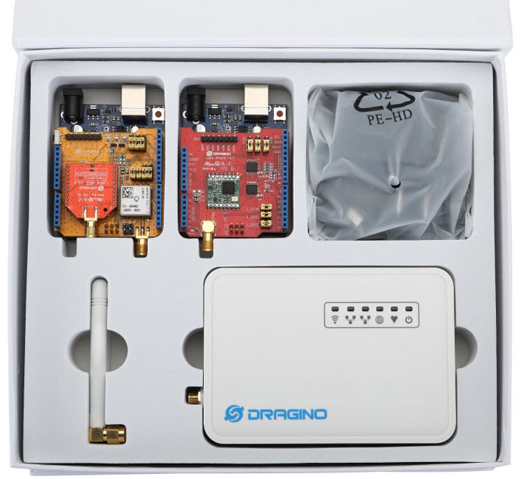
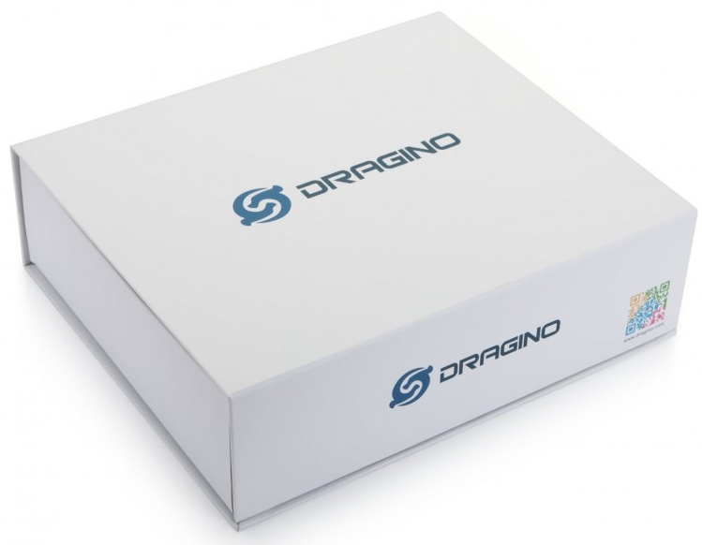

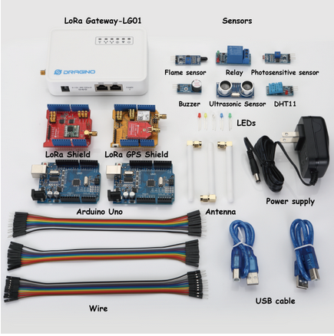
Specifications
Long-range wireless starter Kit is pack of
- 1 x Single Channel LoRa Gateway
- 1 x (LoRa Shield + Arduino UNO)
- 1 x (LoRa/GPS Shield + Arduino UNO)
- 1 x flame sensor
- 1 x Relay
- 1 x photosensitive sensor
- 1 x Buzzer
- 1 x Ultrosonic Sensor
- 1 x DHT11 Temperature and Humidity Sensor
- 20 x dupont wire (male to male)
- 20 x dupont wire (female to female)
- 20 x dupont wire (female to male)

Single Channel LoRa Gateway
- Processor: 400MHz, 24K MIPS
- Flash: 16MB ; RAM: 64MB
- MCU: ATMega328P
- 10M/100M RJ45 Ports x 2
- WiFi : 802.11 b/g/n
- LoRa Wireless
- Power Input: 12V DC
- USB 2.0 host connector x 1
- USB 2.0 host internal interface x 1
- 1 x LoRa Interface
- Open Source OpenWrt system
- Low power consumption
- Firmware upgrade via Web
- Software upgradable via network
- Flexible protocol to connect to IoT servers
- Auto-Provisioning

- Built-in web server
- Managed by Web GUI, SSH via LAN or WiFi
- Internet connection via LAN, WiFi and USB
- Failsafe design provides robustly system
- 1 x SX1276/SX1278 LoRa module
- Limited support in LoRaWAN/ Support Private LoRa protocol
- Support upto 300 nodes
- LoRa band available at 865-867 MHz
- Max range in LoRa: 3~10 km
- Up to 14.4Mbps downlink and 5.76Mbps uplink data rates
- Bullet-proof front end: IIP3 = -12.5 dBm.
- Excellent blocking immunity.

LoRa Shield
- 168 dB maximum link budget.
- +20 dBm - 100 mW constant RF output vs.
- +14 dBm high efficiency PA.
- Programmable bit rate up to 300 kbps.
- High sensitivity: down to -148 dBm.
- Bullet-proof front end: IIP3 = -12.5 dBm.
- Excellent blocking immunity.
- Low RX current of 10.3 mA, 200 nA register retention.
- Fully integrated synthesizer with a resolution of 61Hz.
- FSK, GFSK, MSK, GMSK, LoRaTM and OOK modulation.
- Built-in bit synchronizer for clock recovery.
- Preamble detection.
- 127 dB Dynamic Range RSSI.
- Automatic RF Sense and CAD with ultra-fast AFC.
- Packet engine up to 256 bytes with CRC.
- External Antenna via I-Pex connector

LoRa GPS Shield
- LoRa Shield basic Spec mentioned above along with following GPS Spec
- Power Acquisition: 25mA, Power Tracking: 20mA.
- Compliant with GPS, SBAS.
- Programmable bit rate up to 300 kbps.
- Serial Interfaces UART: Adjustable 4800~115200 bps, Default: 9600bps.
- Update rate: 1Hz (Default), up to10Hz.
- Protocols: NMEA 0183, PMTK.
- Horizontal Position Accuracy: Autonomous <2.5 m CEP.
- TTFF@-130dBm with EASY™: Cold Start <15s, Warm Start <5s,Hot start <1s;TTFF@-130dBm.
- Without EASY™: Cold Start <35s, Warm Start <30s,Hot Start <1s.
- Timing Accuracy: 1PPS out 10ns，Reacquisition Time <1s.
- Velocity Accuracy Without aid <0.1m/s, Acceleration Accuracy Without aid 0.1m/s².
- Sensitivity Acquisition -148dBm，Tracking -165dBm，Reacquisition -160dBm.
- Dynamic Performance Altitude Max.18000m，Maximum Velocity Max.515m/s, Maximum Acceleration 4G.
- L1 Band Receiver (1575.42MHz) Channel 22 (Tracking) /66 (Acquisition).

